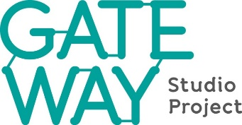

Project Manager, Gateway Studio Project

18 hours per week, initial 3-month contract
£20,000 per annum pro rata

Gateway Studio is a rapidly growing Gateshead-based dance organisation with a strong artistic vision delivering dance education and producing new work. There are plans to develop its grade 1-listed base venue into a centre of arts, heritage and community and a Heritage Lottery Fund development grant has been obtained as the first part of a £1.2 million project.

We are now looking for a project manager to coordinate this project and ensure that all parts of the capital project, heritage programme and funding requirement can be delivered.

Reporting to the project board the responsibilities of the role include:

- Act as principal ambassador of the project
- Develop business and project plans
- Lead tendering and procurement process including compiling tender documents and coordinating selection, contracting and monitoring of contractors
- Manage project budget, timing plan, risk and reporting obligations
- Ensure that recognised best practices and procedures are applied and statutory obligations fulfilled
- Create and deliver funding plan

This is an opportunity for an experienced project manager to be at the centre of an exciting heritage restoration and conversion project.

The successful candidate will be able to demonstrate:

- Strong project management skills
- Excellent communications, relationship and negotiating skills
- Ability to use project and finance spreadsheet tools
- Experience of heritage and construction projects
- Experience of fundraising

A full job description and how to apply are <link to website page>

Closing date for applications: Monday 26th August 2019

Interviews will take place week commencing 9th September.

